Built Environment Neighborhood Affects

Background/Motivation

This research is part of a larger research project for the Pennsylvania Infrastructure Technology Alliance. The point of the overall project is to provide a holistic framework for prioritizing investments in bridge lifting. The project will provide the Pennsylvania Department of Transportation (PennDOT) with a model that will not only incorporate the usual technical and economic costs but also inconvenience costs and community opportunity costs. (Akinci, Armanios, & Qian, 2016) The project for this class is the first step in identifying how bridge height affects the local populace.

If socioeconomic equity factors are included in infrastructure construction and maintenance prioritization calculations, does it change the outcome? Are low bridges barriers to mobility and equity? Environmental Justice and social justice theories make compelling cases for consideration of socioeconomic factors when building and maintaining infrastructure to not perpetuate injustices to the poor and marginalized. However, up to this point, researchers have presented problems but have not posed how these factors can be incorporated into engineering solutions. Very little has been done to advise government agencies on how to improve the situation.

Star discussed the built environment and the ways in which it may inadvertently be a hindrance to some groups. Infrastructure can be a boon to one group but an obstacle to others. Infrastructure becomes inseparable from the tools, rules and politics of the system that built it. (Star, 1999) As such infrastructure can be thought of as a de facto means of implementing policy to modify human behavior. If the policy is intentional, the effects on the local populace is real and if not planned carefully, can have negative effects on the poor and marginalized. Schindler performed a “legal review” and found that discrimination and segregation can be accomplished through physical design and the built environment. She contends that the built environment is rarely even recognized as a form of regulation. (Schindler, 2015) This form of policy is largely ignored and not subject to the same breadth and depth of public and government review. Grabowski, et al, make a case for why infrastructure is a socio-eco-technical system which requires greater interdisciplinarity to overcome and rectify negative consequences to the poor and marginalized. (Grabowski et al., 2017) This research will help to start to inform PennDOT on what factors should be considered in order to more equitably plan bridge construction and maintenance.

Section 1: Data Description

We have access to the PennDOT Bridge Management System version 2 (BMS2) database and the Neighborhood Change Database (normalized to 2010 tract census and American Community Survey (ACS) panelized data from 1970-2010 at the census tract spatial resolution). This “normalization” remapped smaller sub-tract units in previous years to the tract boundaries extant in 2010. (“GeoLytics - US Census demographic and GIS data products,” 2018) I have compiled a data dictionary of the census data I plan to use which can be seen in the Appendix. I have not yet determined which data from BMS2 is pertinent, but I will also attach a data dictionary for BMS2.

Section 2: Planned Analyses

My plan is to use regression analysis to discover correlation and possibly causation of socioeconomic factors affected by bridge height. This will inform additional steps of analysis to aid PennDOT decision making processes. I plan to perform a difference in difference regression for bridges constructed after 1980 but prior to 2000. Due to our panel constraints, this will allow us to have at least two data points prior to and another two data points after construction. The bridge construction year will act as the treatment year. Tracts with under-height bridges (< 14’ clearance) will be compared to similar tracts without under-height bridges.

Hypothesis 1: I hypothesize that bridge height will be found to have a more significant effect on marginalized groups than the general population. These effects may be observed by changes to factors such as minority density in a tract, commute times and modes, household income, education attainment, poverty density in a tract, and occupation of housing units within a tract.

Hypothesis 1a: I hypothesize that the more under-height bridges in a tract, the more negatively impacted those tracts will be in the previously mentioned factors.

Hypothesis 1b: I hypothesize that the more under-height border bridges (bridges within 100m of multiple tracts) will serve as a boundary that will produce divergences in the aforementioned factors where one tract will do worse while a bordering tract will do better.

Hypothesis 2: There will be no significant effect of under-height bridges on tracts and some other omitted variable will have more explanatory power for inequalities.

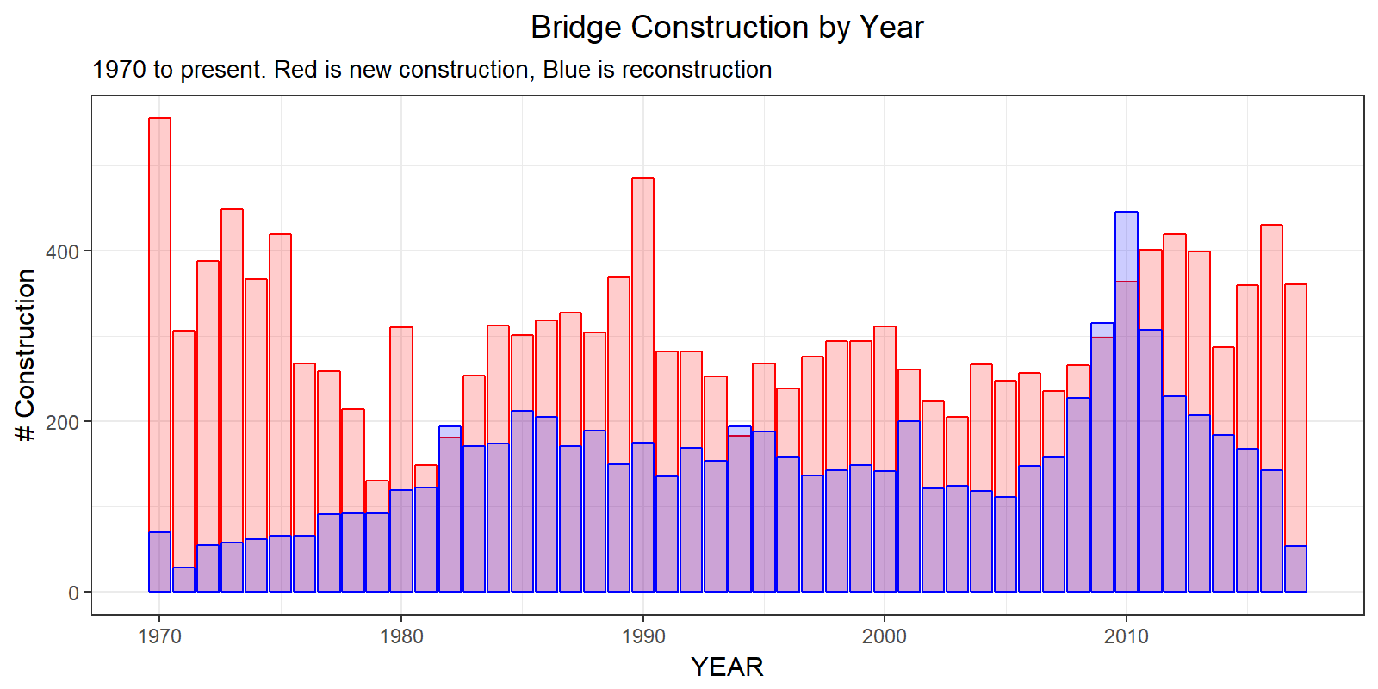

Section 3: Contingency Plans

I may find that hypothesis 2 is accurate and no socioeconomic factors are found to be affected by bridge clearance height. This would mean that there is not a strong case for changing bridge maintenance or lift prioritization. I may have difficulty constructing the proper data set. I have two approaches for the data set at this point. I may use both approaches or only one approach. The first approach is to create aggregated data fields for each tract as follows:

1. Total # (border and non-border) bridges in a tract

2. Average height of total # (border and non-border) bridges in a tract (excluding bridges over 30m)

3. Total # (border and non-border) bridges over 14 ft in a tract

4. Total # (border and non-border) bridges under 14 ft in a tract

5. Total border bridges in a tract

6. Average height of Total border bridges in a tract

7. Total border bridges in a tract over 14 ft in a tract

8. Total border bridges in a tract under 14 ft in a tract

9. Total non-border bridges in a tract

10. Average height of Total non-border bridges in a tract

11. Total non-border bridges in a tract over 14 ft in a tract

12. Total non-border bridges in a tract under 14 ft in a tract

13-21. Total bridges by material type (6A26) [9 columns: steel; concrete (cast in place); concrete (precast); prestressed precast concrete (P/S); timber; masonry; aluminum, wrought iron, cast iron; concrete encased steel; and other]

22-30. Total border bridges by material type (6A26) [9 columns: steel; concrete (cast in place); concrete (precast); prestressed precast concrete (P/S); timber; masonry; aluminum, wrought iron, cast iron; concrete encased steel; and other]

31-38. Total non-border bridges by material type (6A26) [9 columns: steel; concrete (cast in place); concrete (precast); prestressed precast concrete (P/S); timber; masonry; aluminum, wrought iron, cast iron; concrete encased steel; and other] (Pennsylvania Department of Transportation, 2009, pp. 3–117)

The second approach is to first create a dummy variable designating whether a bridge is classified as a border bridge. Second, I would merge each bridge with the tracts it is in or borders. This would make a much larger panel and may be computationally unwieldy, but it would allow the regression to be run for each bridge instead of the aggregate.

Section 4: Exploratory Analyses

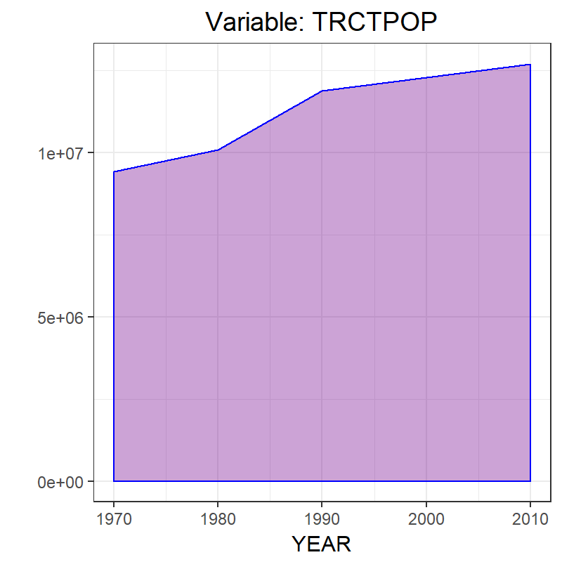Up to this point, I have only done some data analysis of the Neighborhood Change Database Census data and of a publicly available data set about the bridges that does not include underclearance heights. I’ve only look at the histograms and summations of the variables over time. Here are examples of tract populations.

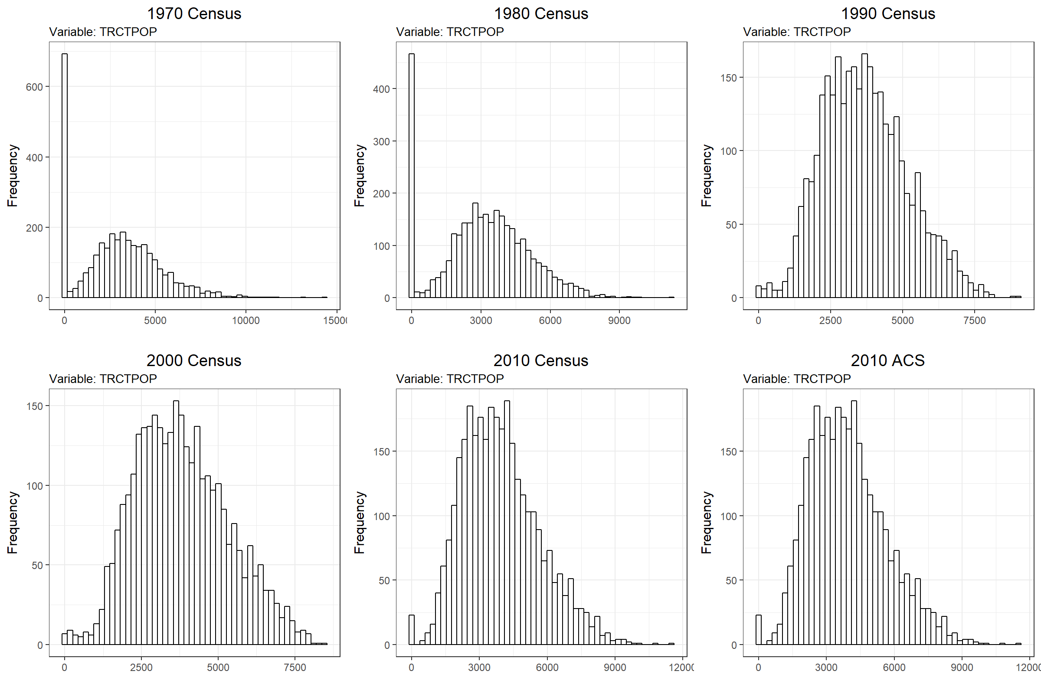

Section 5: Sensitivity Analyses

I envision that the model will look something like the following example using population as the dependent variable, but additional variables will be used as the independent variable. This would be for the case where I merged each individual bridge into the panel dataset.

$${population}_{it}= β_{0}+ β_{1it}{underclearance}_{it}+ e_{it}$$

The *i* for the population is the tract, while the *i* for the underclearance is the bridge.

Using approach one it would look more like this using the 38 variables from above:

$${population}_{it}= β_{0}+ β_{1it}{var}_{1it}+…+β_{38it}{var}_{38it}+ e_{it}$$

The *i* for all variables in this case is the tract.

Section 6: Pre-registration

I looked at OSF.io, but didn’t want to create another account for what appears to be another GitHub-like space. So, I have posted this on my GitHub repository as a form of pre-registration, as requested, here:

<https://github.com/ZhongSiming>

It appeared that the point of pre-registering was to create a paper trail to see how the analysis changed over time. GitHub will do this. If I have misunderstood the requirement, please let me know and I will post a copy of this to OSF.io as well.

**Bibliography**

Akinci, B., Armanios, D., & Qian, Z. (Sean). (2016). A Holistic Framework for Prioritizing Investments in Bridge Lifting.

GeoLytics - US Census demographic and GIS data products. (2018). Retrieved April 22, 2018, from http://www.geolytics.com/USCensus,Neighborhood-Change-Database-1970-2000,Products.asp

Grabowski, Z. J., Matsler, A. M., Thiel, C., McPhillips, L., Hum, R., Bradshaw, A., … Redman, C. (2017). Infrastructures as Socio-Eco-Technical Systems: Five Considerations for Interdisciplinary Dialogue. *Journal of Infrastructure Systems*, *23*(4), 02517002. https://doi.org/10.1061/(ASCE)IS.1943-555X.0000383

Pennsylvania Department of Transportation. (2009, August 20). PUB 100A Bridge Management System 2 (BMS2) Coding Manual, Publication 100A, July 2009 Edition. Pennsylvania Department of Transportation. Retrieved from www.dot.state.pa.us

Schindler, S. (2015). Architectural Exclusion: Discrimination and Segregation Through Physical Design of the Built Environment. *The Yale Law Journal*, (124), 1934–2024.

Star, S. L. (1999). The Ethnography of Infrastructure. *American Behavioral Scientist*, *43*(3), 377–391. https://doi.org/10.1177/00027649921955326